**August 3, 2016**

**Volume 21, Issue 5**

**www.boonerotary.com**

**Rotary Buzzer**

# Meeting Recap

**August 10**

**RYLA Recap—Isidro and other RYLA participants**

**August 12**

**Meeting Des Moines AM Club. Will leave Boone at 6:00 AM for those going**

**August 17**

**DG Chris Knapp’s Annual Club Visit**

**August 24**

**Pufferbilly Work Day**

**August 31**

**Brad Manard, Program Chair**

**September 7**

**Steve Dakin, Program Chair**

**September 14**

**Andrew Schroeder, Program Chair**

**September 21**

**Jeff Anderson, Editor**

**Pres. Troy Thompson**

**Dist. Gov. Chris Knapp**

**ADG Steve Dakin**

**RI Pres. John Germ**

Pres. Troy was gone on Wednesday so Pres. Elect Andrew was called into service! He did express appreciation for the detailed notes that Troy left to help him out. There were several guests and visitors including Isidro (who will be heading up our program on RYLA next week) and Mary Maybee who was visiting as George’s guest. Also visiting were Sam (Duncan) Perry who was visiting with Megan. Sam just started at Boone Bank on August 1st. Also with us again was Jim Riordan who is in the process of transferring his membership from the Waukee Rotary Club. Jim has been a Rotarian since 1999 and recently moved back to Boone (his hometown)!

**PUFFERBILLY DAYS**

Andrew mentioned that Troy and Lisa are putting together plans for our participation in the Pufferbilly Days Parade on September 10th. Walkers are needed to traverse the parade route so please let Lisa or Troy know if you will be available that morning.

**Dictionary Project**

Mary Youngblood reported that the dictionaries that we distribute to all Boone County third graders have arrived. Next week we will be placing the Boone Rotary labels with the Four Way Test inside the covers of the dictionaries. Mary also passed around the signup sheet for the different schools. She asked the coordinator volunteers for each building to please contact the secretaries to find out how many third graders there are by August 30th. The plan is to distribute the dictionaries by mid-September (Reminder to the coordinators: please be sure to get a picture of your distributing the dictionaries!). Speaking of books, books are still needed to replenish the collection at the Little Lending Library that Troy constructed and placed on Story Street.

Sergeant at Arms Cody collected happy dollars from Phil who had a nice vacation in New England AND who found out he is going to be a grandpa again! Kurt had a nice vacation in (MN?) as well and he paid another $5 for the nice plub that Mary Maybee put in for volunteering in the Boone County Tourism booth at the upcoming Iowa State Fair (free admission if you volunteer—see Kurt for the details). Mary was happy that he son, granddaughter, and great granddaughter were visiting and George was h appy to have Mara MacKay as our speaker and encouraged everyone to consider supporting the Historical Center’s capital campaign. It was noted that board has decided to contribute $500 towards this cause as well! Megan was happy to have Sam as her guest and Mary D. was happy that her husband was celebrating his birthday. Jeff was happy to be celebrating his 31st wedding anniversary. Tim was happy to have climbed a “14000 footer” with his daughter and Amy reported that picture of Jeff with Juliette she posted on club’s Facebook had 90% more views than average and Brian was happy we have a new general surgeon and podiatric surgeon in town.

**SERGEANT AT ARMS**



George Maybee introduced Mara MacKay, the executive director for the Boone History Museums. Mara took over as executive director just a few months ago and, after only a month or so on the job, a portion of the façade on the Boone County Historical Center fell off. Mara shared that over the years, water had gotten behind some of the 250lb stone pieces, creating a “trough” that gradually separated the stones from the building. Although the repair was somewhat costly, the “good news” is that rest of the building is structurally very sound and, now that it has been recently re-tuck pointed shouldn’t need major repairs for another 20-30 years. She did say that the “inside” was another matter, and several significant updates will be required including a $40,000 upgrade that is required in order for existing elevator to continue to be used. The security system also required updating as does the HVAC system. She did say the In all the cost of outside repairs and tuckpointing came to around $100,000 which they are trying to raise in the coming months to avoid having to take out a loan. The Leonard Good Trust stepped up with funding to make sure some of the most pressing repairs could be performed. Mara is also apply for an “Enhance Iowa” grant to cover some of these costs as well. Mara presented so cool t shirts to Phil (who came from the greatest distance) and Mary Younglood (who has the most children) that have been created in the last few months (and others will soon be available as well).

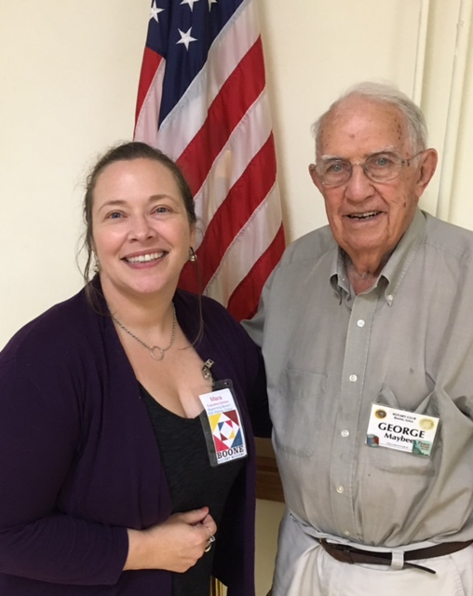

Boone History Museum Ex. Dir. Mara MacKay with George Maybee

**Mara MacKay, Exec. Dir. Boone History Museums**

Quote of the Week

Most of us spend too much time on the last twenty-four hours and too little on the last six thousand years.

Will Durant

American Historian, 1885-1981

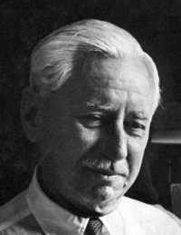

**Some**

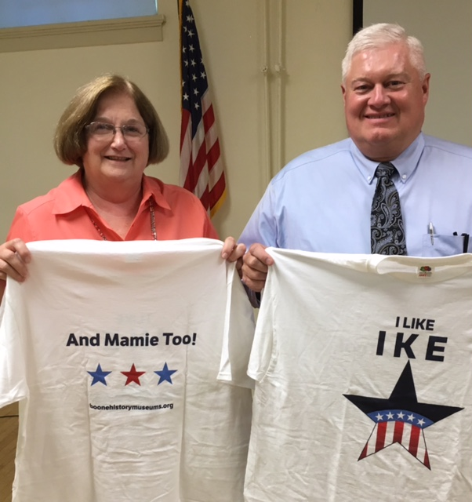

Mary and Phil showing off the front and back of the t shirts Mara awarded them!