**July 27, 2016**

**Volume 21, Issue 4**

**www.boonerotary.com**

**Rotary Buzzer**

# Meeting Recap

**August 3**

**Mara MacKay, Boone County Historical Center**

**George Maybee, Program Chair**

**August 10**

**RYLA Recap—Isidro and other RYLA participants**

**August 12**

**Meeting Des Moines AM Club. Will leave Boone at 6:00 AM for those going**

**August 17**

**DG Chris Knapp’s Annual Club Visit**

**August 24**

**Pufferbilly Work Day**

**August 31**

**Brad Manard, Program Chair**

**September 7**

**Steve Dakin, Program Chair**

**September 14**

**Andrew Schroeder, Program Chair**

**Jeff Anderson, Editor**

**Pres. Troy Thompson**

**Dist. Gov. Chris Knapp**

**RI Pres. John Germ**

Pres. Troy called the meeting to order and welcomed several guests including Isidro, Katelyn Mehlhaus, and Mylie Haden who is a cadet (intern) with the Salvation Army. Isidro served as a RYLA counselor this past week and Katelyn was a RYLA participant. Susan also spent the week at RYLA! Also with us on Wednesday was Jim Riordan who has been a member of Rotary in the Waukee area. Jim is a Boone native and recently moved back to town and will be transferring his membership to our club! Welcome (back) to Boone and to the Boone Rotary Club, Jim!

Troy shared that plans to attend a meeting of the Des Moines AM Rotary Club have changed and will now take place on August 19th. The meeting is at 7:00 AM so those planning to visit will be leaving Boone about 6:00. Please let Troy know if you are interested in attending.

Troy also spotted Isidro a few Euros for his upcoming stay as RYE student in Italy!

**PUFFERBILLY DAYS**

Troy and Lisa are putting together plans for our participation in the Pufferbilly Days Parade on September 10th. The tentative plan is for Troy’s Kubota to be the “vehicle” and to try and affix signs promoting our pulled pork dinner in some fashion. Walkers are needed as well to traverse the parade route. Please let Lisa or Troy know if you will be available that morning.

**Little Lending Library Book Appeal**

Books are needed to replenish the collection of the Little Lending Library that Troy constructed and placed on Story Street. Children’s books in particular are needed but if you have other books that you’d like to donate just bring them to a meeting as well.

Sergeant Cody had a great time camping in South Dakota and Ken was happy he didn’t lose any more of his fingertip than he did in a “carpentry mishap”! Mary Youngblood appreciated the help she received carrying the dictionaries and Mary Dufelmeier had a good time with 6 of her 9 grandchildren at a lake in MN. Becky shared that she is traveling to Nashville this week to see if she can make it in the music business…but if it doesn’t work out she’ll be back next week! Dave Cook contributed $59 to our Boone Rotary Foundation in recognition of having completed 59 trips around the Sun and Amy shared that one of her running partners is taking the week “off” to serve as the guide/lead rider on a tandem bike along with a visually impaired rider on RAGBRAI. Jeff had a great trip to Europe and had the opportunity to see two former exchange students who lived with them including RYE student Juliette Reheul from Belgium when he was in Amsterdam. She’s doing great and says “Hi” to everyone in the Boone!

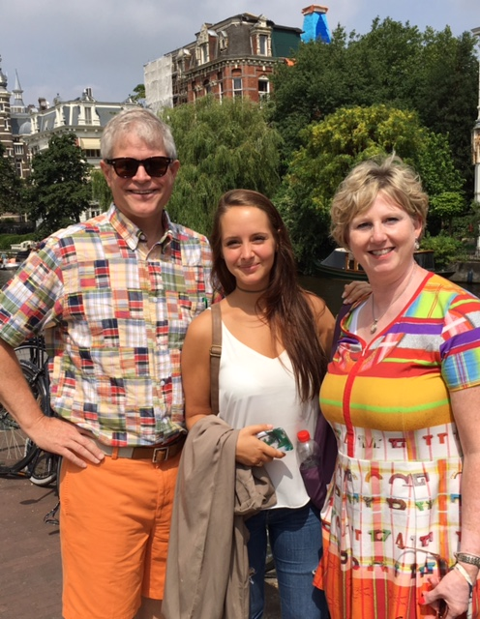

**SERGEANT AT ARMS**



Becky Dose introduced former Boone High English teacher Chuck Behm who began by sharing that he was going to share about how he has tried to reach out and touch the world without leaving Boone! Chuck shared that he had tuned piano’s on part-time basis for many years but after he retired from teaching (school!) in 2006 he began devoting more of his time and energy to his passion for tuning and restoring pianos. He joined the Piano Technician Guild which has over 4500 members around the world. The organization has a journal that has been published monthly since 1958 and Chuck decided in 2007 to combine his passion for piano restoration with his writing background and submitted an article on a “piano trolley” that he devised to help keep the parts organized when the instrument was disassembled for publication. It was accepted and since that time he has had dozens of articles published in the journal and he is currently doing a series of 48 articles (over four years) providing step by step guidance for complete restoration of an upright piano! A number of his articles have been translated into Spanish, German and, most recently, Chinese—so he really is reaching out and touching the World from his workshop in Boone! One of Chuck’s high profiled local efforts has been the colorful “outdoor piano” that is currently located outside the Dutch Oven Bakery. He is also teaching a class on piano restoration in his workshop with students from New York, California and Missouri having traveled to Boone to get this experience. Chuck shared that he and former Boone High Band director Dave Richardson restore between 6-8 pianos a year, which keeps them very busy. Thanks to Chuck for a fascinating program!

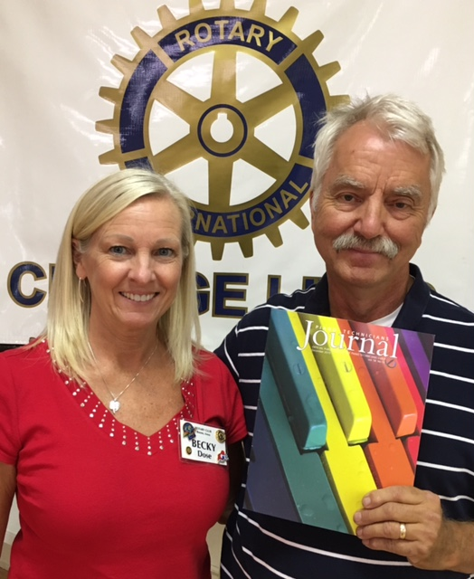

Becky Dose with Chuck Behm. Chuck is holding the copy of the Journal with a picture of Boone's outdoor piano on it!

**Chuck Behm, Reaching out to Touch the World from Boone, Iowa**

Quote of the Week

Life is like a piano. What you get out of it depends on how you play it.

Tom Lehrer, pianist and humorist

[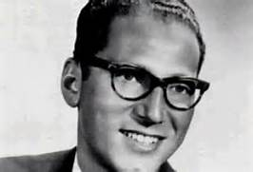](https://www.bing.com/images/search?q=tom+lehrer&view=detailv2&qpvt=tom+lehrer&id=BD143B9C04170DD6DE3CEEFD3C0FFF65697263E3&selectedIndex=11&ccid=tq2ngJn/&simid=608020907525867191&thid=OIP.Mb6ada78099ffd9cf0864ce387eedbc43o1)

**Some**

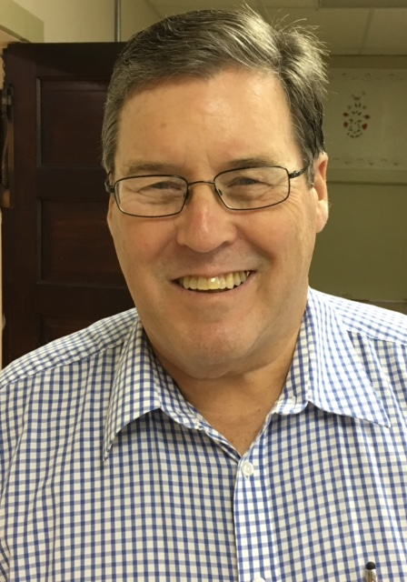

Boone Native and current Rotarian Jim Riordan will be transferring his membership to our club. Please be sure to introduce yourself to Jim!