**July 20, 2016**

**Volume 21, Issue 3**

**www.boonerotary.com**

**Rotary Buzzer**

# Meeting Recap

**July 27**

**Chuck Behm**

**Becky Dose, Program Chair**

**August 3**

**Mara MacKay, Boone County Historical Center**

**George Maybee, Program Chair**

**August 10**

**Possibly RYLA Recap**

**August 12**

**Meeting Des Moines AM Club. Will leave Boone at 6:00 AM for those going**

**August 17**

**DG Chris Knapp’s Annual Club Visit**

**August 24**

**Pufferbilly Work Day**

**August 31**

**Brad Manard, Program Chair**

**September 7**

**Steve Dakin, Program Chair**

**September 14**

**Andrew Schroeder, Program Chair**

**Jeff Anderson, Editor**

**Pres. Troy Thompson**

**Dist. Gov. Chris Knapp**

**RI Pres. John Germ**

Thanks to Mary for taking notes of the meeting in my absence last week. Pres. Troy called the meeting to order and shared the Quote for the Day – *Failure is the condiment that gives success its flavor*. Truman Capote

We did a flip flop of the meeting today, starting with the program as they had to be back to work but we will pretend for the sake of consistency (in the Buzzer) that our “business” still came first!

Craig said he got a thank you from the Iowa Games for our work as road marshals. Thanks to everyone who came out on the 17th to help with this project.

Steve spent time with District Governor Chris Knapp last weekend. Governor Chris will be in Boone for his annual club visit in just a few weeks on August 17th! Steve would also like to find a way that our Club could express support for Law Enforcement. Troy asked everyone to be thinking about that and let them know of any ideas.

Dave reported that on June 7 our district foundation giving was $355/member. In the last few weeks $1,700 more was contributed by members making our total $403.76 by the end of the Rotary year.

West Liberty’s giving on June 7 was $359/member and they contributed $7,000 more in the last few weeks making their final total $538/member.  Although they nipped up by a bit in the end for “first place”, our club should be very proud of the support we have provided to the Rotary Foundation this past year. Way to go!

Troy also wants members to consider walking in this year’s Pufferbilly Days Parade. If you are able to walk (in the parade) just let Troy know!

Past president Pete filled in for Cody as sergeant at Arms on Wednesday and collected a number of happy dollars from members for our speakers and for another year of successfully keeping riders in the Iowa Games Cycling Race safe! Dave stated he was happy to see the turnout was still good considering how hard it was raining at 6:30 that morning. Megan was happy that her twins turn five this week and Amy was happy that her daughter will be cheerleader at the middle school (and she must sell 15 activities calendars. If anyone wants one, contact her—I’ll take two Amy! Steve was happy about our 2nd place finish in per capita foundation giving. Brian hasn’t heard from his daughter lately so he is assuming she is having a great time in Ireland and Ken noted that his father, Bill Curell, worked at Redeker’s for 30+ years and his brother Jim worked there for 30+ years and he worked there for 14 years.

**SERGEANT AT ARMS**



Vern introduced Mike and Grant Redeker. Mike shared that he and Grant are 4th generation members in the family-owned furniture business. Fred Redeker started the business in 1930 in the location on Story Street where Modern Dress is now. Mike’s wife, Ashley owns that building now so it’s back in the family! When she was moving in, before they were married, they found an old sign upstairs that said “Let Redekers feather your nest with Quality Furniture”. In 1957 they moved to the building that houses Tic Toc on Keeler Street. Stan Redeker went to Stanford for basketball and did not think he would be coming back to Iowa when he graduated. Things have a way of happening and when his father, Fred, had some health problems, he made the decision to return to Iowa and help in the store. Stan handled the advertising and marketing and was the one who started advertising outside of Boone, increasing their business. In 1968 they made the decision to move to the South Story location and built their building in a corn field. Joe (Mike and Grant’s father) joined the company after he graduated from college and in 2008 Mike joined, followed by Grant in 2012.  After four additions to the store the decision to move came about because of several problems they were having. They were landlocked in their current location with nowhere to expand. They had a huge inefficiency problem with their warehouse across Marshall Street from the main store. They researched what they wanted to do for several years, visiting furniture stores around the Midwest. What they came up with was the things they didn’t want to do. They knew they wanted to increase the size of the store but they didn’t want it to feel like an industrial box store, they wanted a residential feel for their customers.  Joe is credited with the inspiration for the new store. While on a business trip he was in an airport and thought how great it would work as a furniture store with all the windows on all sides.  So the “Y” shaped showroom was developed, allowing natural light to come in on all sides, so customers can better choose fabric and wood colors for their homes. They also added a drive up door to make it easy for customers to pick up furniture instead of having it delivered. They opened the doors of the new store in October of 2015, surrounded again by a corn field, and now employ about 55-65 people!

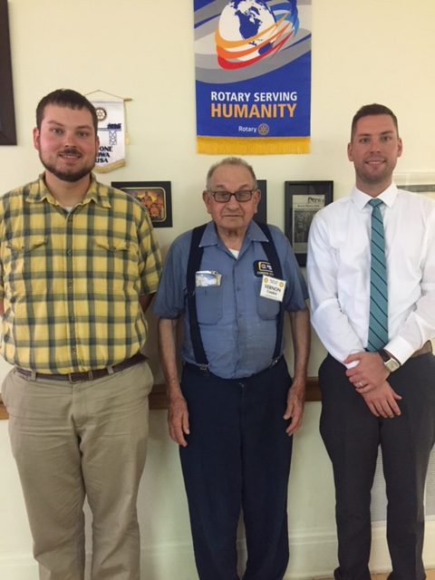

Grant and Mike Redeker of Redekers—serving as bookends for Vern on Wednesday!

**Redeker’s Furniture**

Quote of the Week

Get your facts first, then you can distort them as you please.

Mark Twain



**Some**

SEE YOU WEDNESDAY!